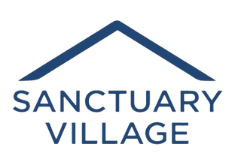
Get ready for Sanctuary Village’s silent auction on February 24-26!! The link will go live on Friday (from the www.tinyhousecommunity.org site). Be sure to sign on and participate to score lots of great items: gift certificates for restaurants, tickets for the Flower Show, Longwood, Morris Arboretum..... even antique beer steins! Definitely something for everyone.
Please spread the word and sign on over the weekend. Whatever you purchase gets you a great deal and helps someone finally have shelter and a safe future.

